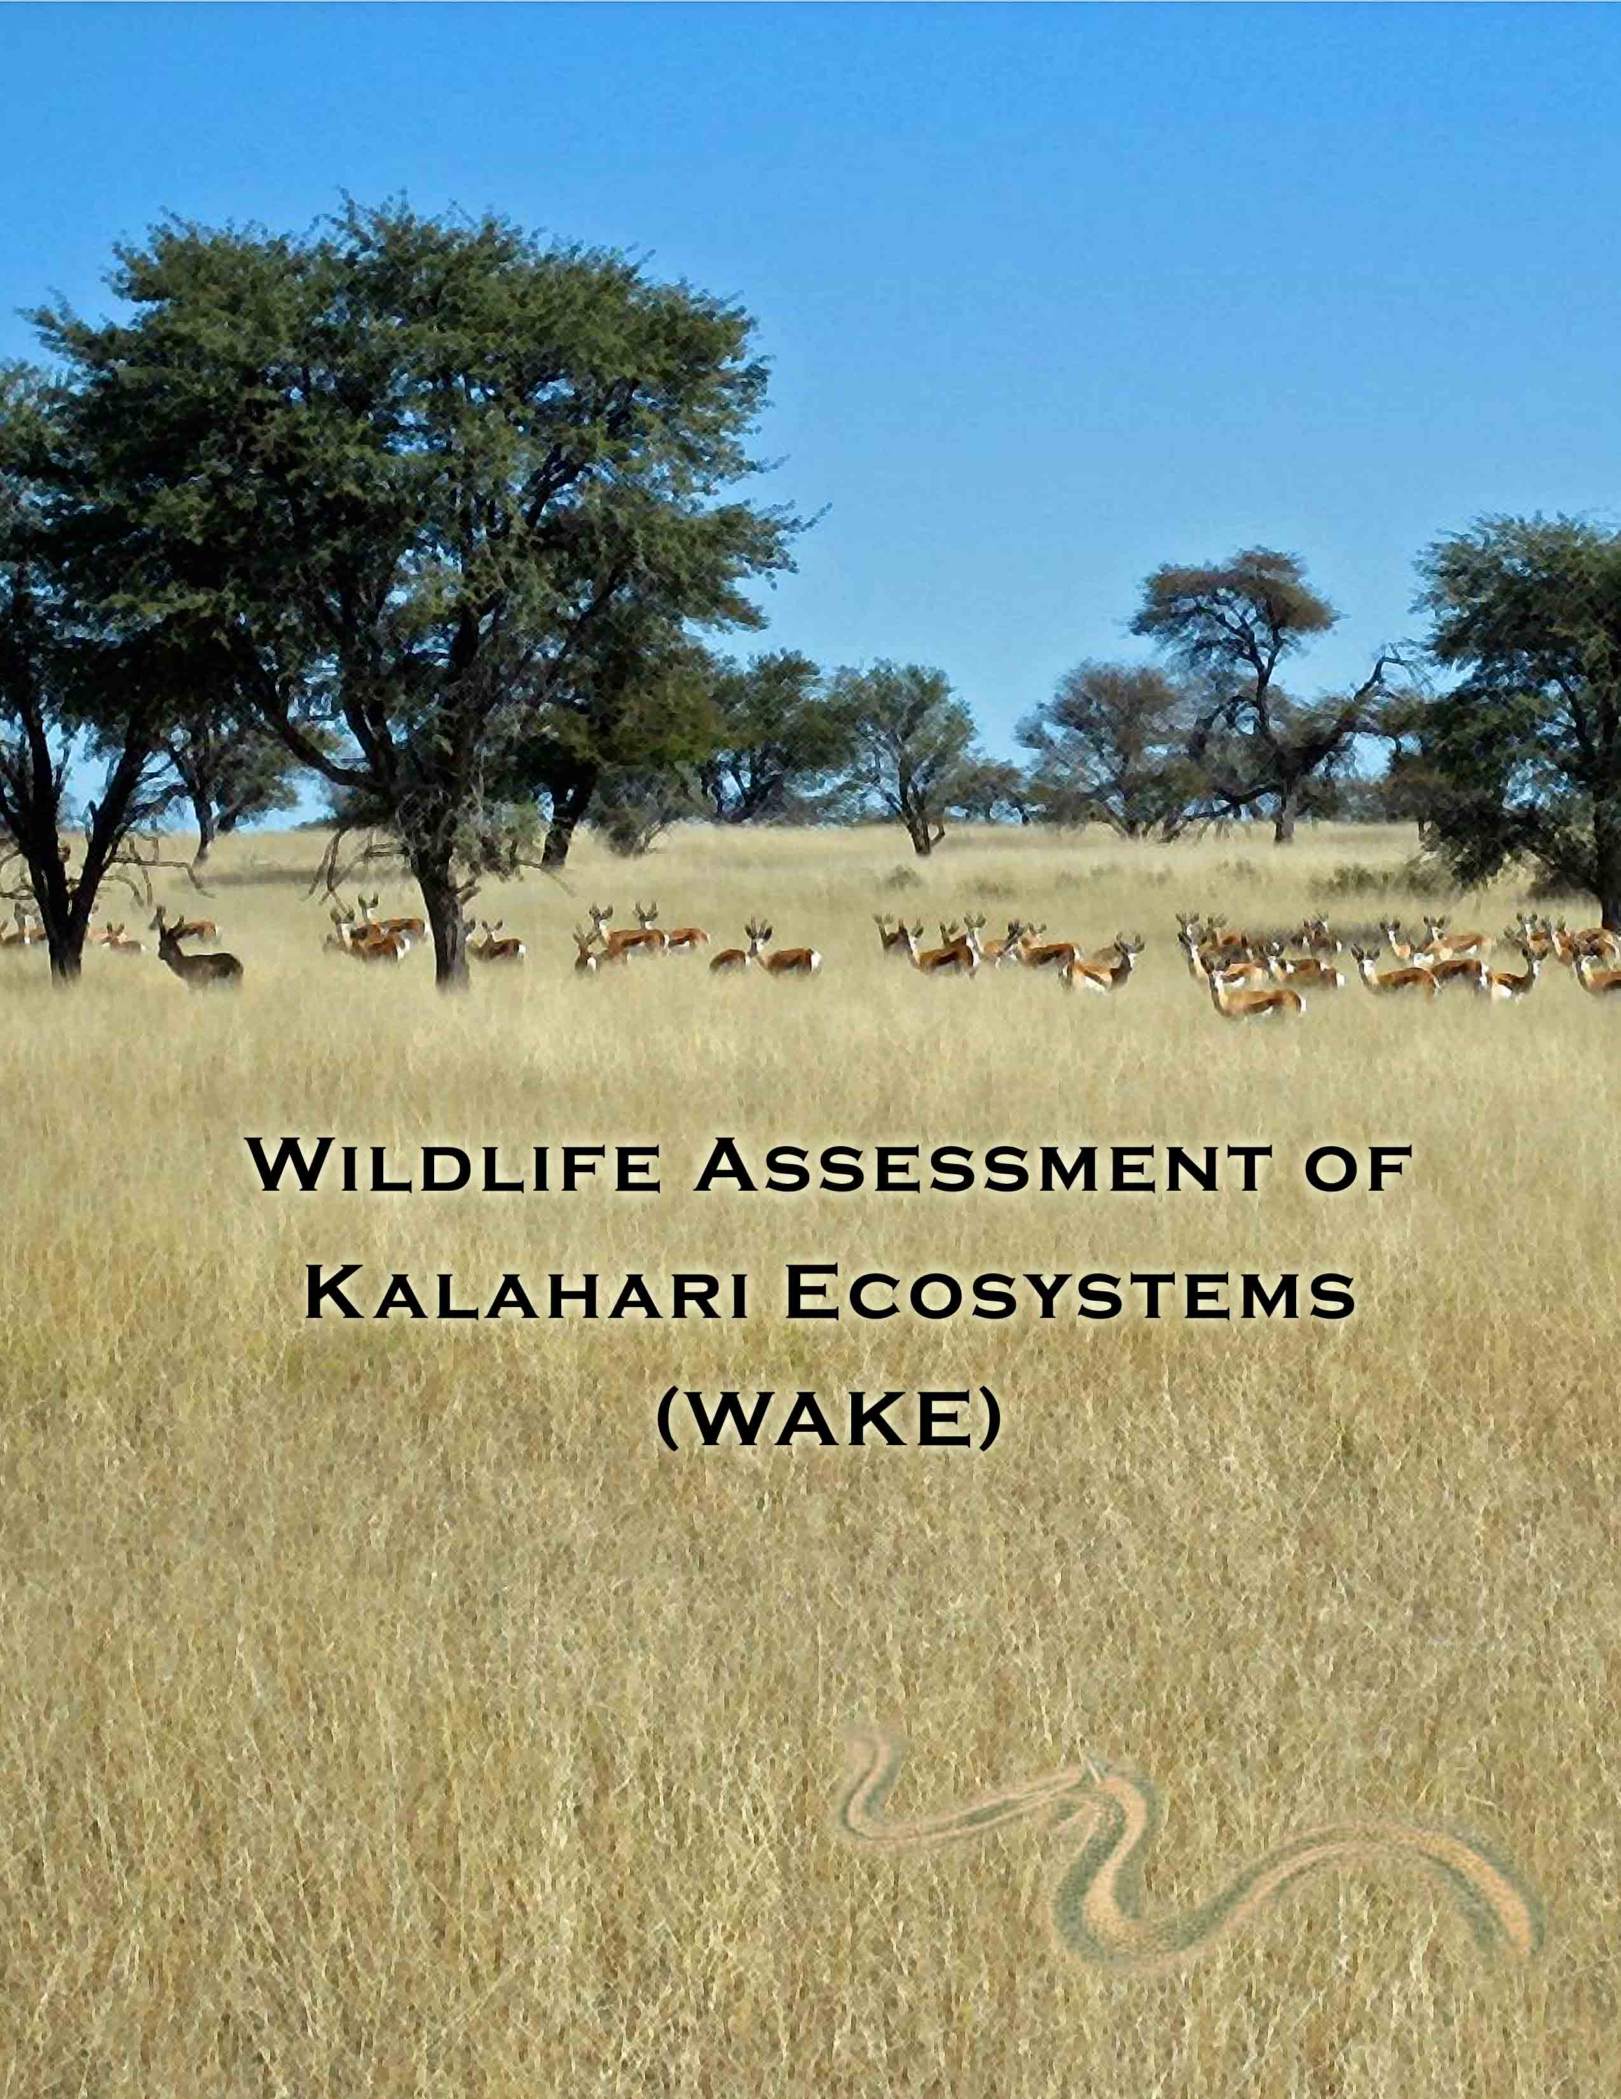

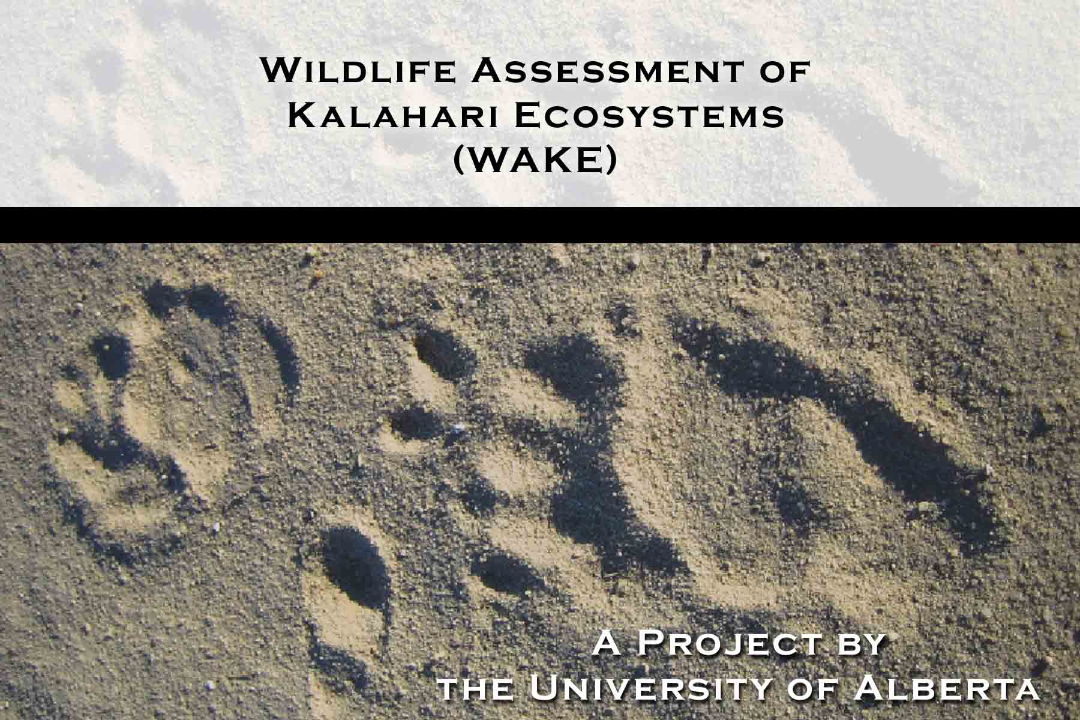

Dr. A. Lee Foote
Associate Professor
IUCN Sustainable Use Specialist Group, North American Chair
Email: Lee.Foote@afhe.ualberta.ca Ph: (01) 780 492 4020 fax: (01) 780 492 4323
Department of Renewable Resources, University of Alberta
Edmonton, Alberta, Canada
T6G 2H1

Derek Keeping, Graduate Student
Email: dkeeping@ualberta.ca Ph: (01) 780 492 2540(work) (01) 780 433 8043(home)
Department of Renewable Resources
751 General Services Building, University of Alberta
Edmonton, Alberta, Canada
T6G 2H1


Executive Summary:

Southwestern Botswana is a vast wilderness of dry Kalahari savanna, home to a suite of free-ranging large African mammals and a very small human population living in a few scattered settlements. Despite a number of increasing threats to the region, the abundance, distributions, and movements of mammalian wildlife are poorly understood. Further, local economies rely on wildlife almost exclusively through subsistence hunting and gathering and ecotourism including photographic and hunting safaris. Current knowledge of wildlife population trends is based upon surveys conducted from an airplane. Due to poor coverage and numerous visibility biases inherent in aerial surveys, they provide very rough estimates of wildlife populations. All species are undercounted and many species are never detected at all. The prudence principle forces those who set harvest and hunting regulations to be deliberately conservative in their allocations. In an attempt to pioneer more effective and efficient ways of data gathering, we will test an animal track-based monitoring method with the assistance of local indigenous !Xo Bushman (San) trackers. This method eliminates visibility biases and detects many species not seen during aerial surveys. By coordinating aerial surveys to overlap on-ground track transect surveys we will be able to estimate visibility correction factors (VCFs) to improve population estimates. Abundance indices determined from track counts will also provide a second, robust data set to detect changes in populations through time and by habitat types. With our tracking partners, we will establish and maintain a series of track transects across a large geographic area that will be sampled throughout wet and dry seasons. With these data we will assess relative abundances of Kalahari mammals by habitat type and land use through time, examine annual distributions and movements throughout the study landscape, and characterize community composition and habitat associations of rare and lesser-known species. The potential of this work is not only informing conservation planning and sustainable wildlife use but in collaborating and building capacity within the local community trust to monitor wildlife themselves. This work will help build a foundation for self-sustaining biodiversity monitoring that is relatively inexpensive, practical, scientifically-defensible, and emphasizes existing indigenous tracking skills.

introduction:
  - Conservation Issue
Stratified transect sampling with aircraft is the established method of monitoring wildlife in the Kalahari, where approximately 4% of the area is surveyed every few years. The aerial surveys provide population estimates, and ultimately, harvest quotas for large mammal species and ostrich; however, due to numerous visibility biases inherent in aerial surveys, undercounting is the norm. Small herbivores, large and small carnivores, insectivores, and all nocturnal species are rarely, if ever detected. Aerial survey bias is not constant in space and time, nor is relative detection bias for large mammals known, making estimates of population size used in monitoring trends of questionable accuracy ^{1, 2}. Harvest quotas for certain wildlife species and land use decisions are based upon this limited information. Poor coverage and inaccuracies in population estimates throws into question the use of this single data source in setting annual harvest quotas and making effective land use and conservation decisions. Further, wildlife sustainability is facing future uncertainty with regards to human population and livestock increases, modern infrastructure developments, potential diamond exploration and extraction, and climate change. In spite of these increasing threats, accurate abundance estimates, distributions, and knowledge of habitat associations do not exist for most species in this vast, remote, largely intact, and under-researched quarter of Africa. As this area is poised for future development, and local economies are nearly entirely wildlife-based, there is a strong conservation need for baseline data on a full range of mammalian diversity plus a monitoring technique that is employable by local communities.

b. How Project Addresses Conservation Issue
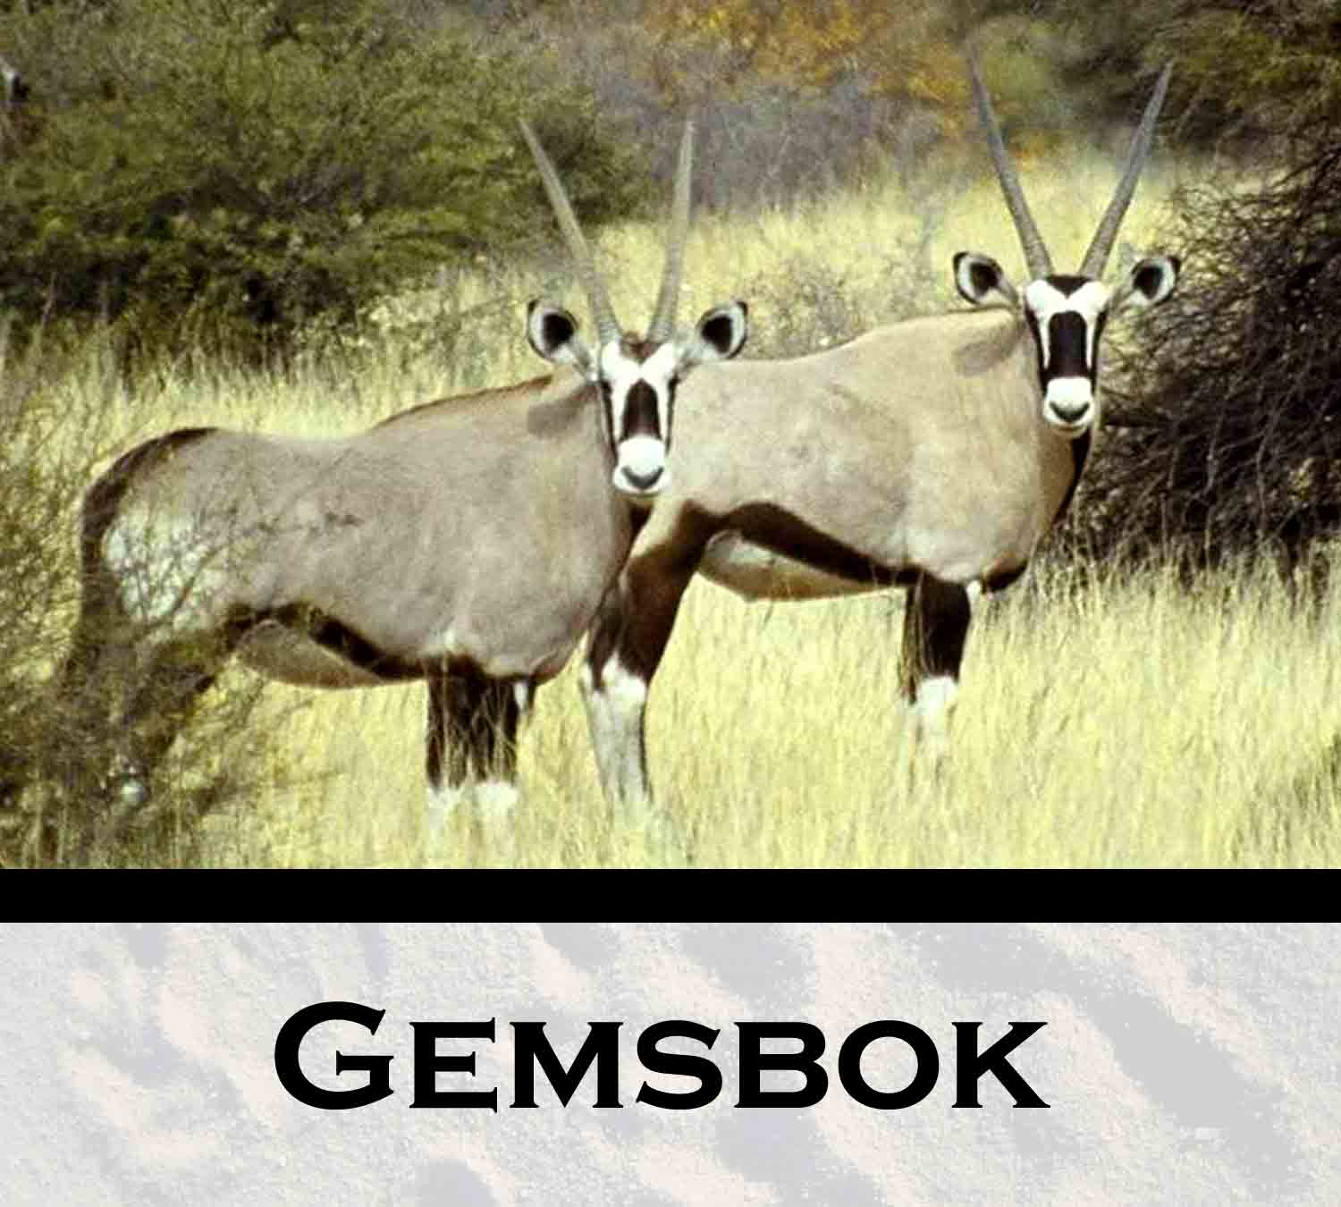
We propose to address this need for improved wildlife population estimates and increased community participation in monitoring by testing a standardized track transect approach with the help of local Bushmen and Bakgalagadi trackers. This method features local traditional knowledge and expertise, eliminates visibility biases, and detects many species not seen during aerial surveys. I am confident we can improve abundance estimation by habitat type, land use, and season for large herbivores such as Gemsbok (Oryx gazella), Eland (Taurotragus oryx), Wildebeest (Connochaetes taurinus), Hartebeest (Alcelaphus buselaphus) and Springbok (Antidorcas marsupialis); rare species such as Black-footed cat (Felis nigripes), Caracal (Caracal caracal) and Honey badger (Mellivora capensis); nocturnal species such as Pangolin (Manis temminckii), Aardvark (Orycteropus afer), Aardwolf (Proteles cristatus) and Brown hyena (Hyaena brunnea); conservation-priority species such as Cheetah (Acinonyx jubatus), Wild dog (Lycaon pictus), and Kori bustard (Ardeotis kori); and controversial game species such as Lion (Panthera leo), and Leopard (Panthera paradis). This project will provide visibility correction factors for aerial surveys, local employment, improved knowledge of species associations with other species and landscape attributes, and invaluable baseline abundance indices and habitat-use data for a full range of mammalian fauna including rare, lesser known, and threatened, endangered species as well as data-deficient game species that will benefit from informed harvest management.
Collaboration between traditional experts and researchers provides a unique opportunity to develop a monitoring system that is custom fit to the region, emphasizing existing traditional skills. Aside from improving our knowledge of wildlife abundance, associations, and movements, a major goal is to complete a project which will be an important step in the much needed community-based wildlife monitoring program for the southwestern Kalahari. A functional track-based monitoring program will be complementary to aerial surveys and aid in decentralizing wildlife management to local communities. The appeal of this track transect approach is enhanced by the fact that it is inexpensive, low-tech, and almost completely non-invasive for the wildlife studied. No wildlife handling is required. The low-tech nature of this method also makes it low risk and less prone to equipment or personnel failure. Improved monitoring will permit better decision-making regarding wildlife conservation, and improve indigenous livelihoods through sustainable wildlife use and more informed ecotourism practices. Additionally, the survey method is transferable to other CBNRM and protected areas of Botswana and further sand regions throughout Africa.

Background information:
a. Study Area
This work will take place in the Kgalagadi District covering the southwestern part of Botswana. The study area covers almost 40,000 km² and includes the Kgalagadi Transfrontier Park (KTFP) and adjacent Wildlife Management Areas (WMAs) including KD1, KD2, and KD3. The study area can be stratified into three categories of human disturbance intensity. This existing gradient of a) low, b) moderate, and c) high human land use corresponds to: a) the strictly protected, minimal tourist access areas within the KTFP in the south; b) adjacent wildlife management areas (WMAs) consisting of photographic safari blocks, and subsistence and private hunting concession blocks; and c) livestock grazing/subsistence gathering/grass, poles, and firewood collection areas within a 20km radius of settlements and bordering the WMAs. Track data will be sampled from each of these areas along approximately 5 transects (20-30 km long each) within each land use type.
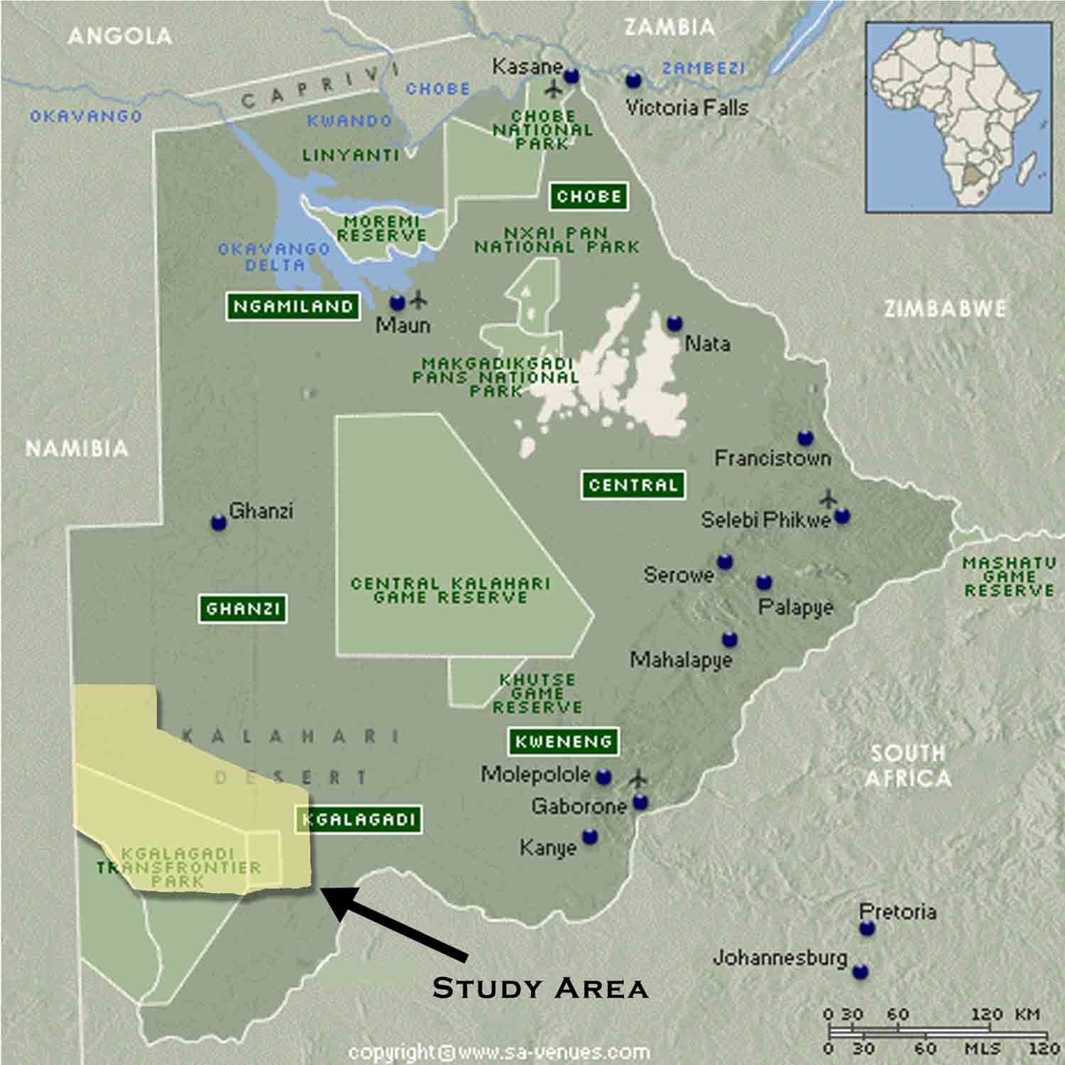

  - Prior Research
Large, semi-migratory ungulates have experienced dramatic declines in the past 50 years due to disruption of historical migration patterns ^{5, 6} and degradation of habitat quality ¹¹. As wildlife declines have been noted outside of the Kgalagadi Transfrontier Park (KTFP), Bonifica ¹² and DWNP ⁴ noted no declines for less migratory species in the protected KTFP. Documented declines in large raptors and ground-dwelling birds such as Kori bustard have been recorded outside of protected areas ¹³. Verlinden ¹⁴ noted that significant declines occurred in migratory mammal species while less migratory species seemed much less affected. Although declines in large migratory herbivores and large raptors have been noted, little is known about population trends of other wildlife species.
Since the 1970s, land use and vegetation cover shifts have occurred in the area, including a decrease in grass cover and subsequent increase in woody vegetation (bush encroachment) up to 18km from settlements and stock watering points ¹⁵. Using coarse resolution aerial survey and environmental data on vegetation cover and fire distribution, Verlinden ¹⁶ demonstrated differences in wildlife and livestock distributions. In general, it was found that Gemsbok, Wildebeest, Hartebeest, and Eland avoid livestock areas, while Ostrich (Struthio camelus), Common Duiker (Sylvicapra grimmia), Steenbok (Raphicerus campestris), and Springbok are less influenced by overgrazed areas and human settlements. Some research in the area has examined differences in presence and abundance of wildlife between land use areas. Recent researches by students from the University of Uppsala, Sweden, indicate that the disturbance gradient in land use intensity and human impact (livestock/village surroundings to national parks) affected large mammals ^{17, 18, 19}, small mammals ²⁰ and insect communities ²¹. Hunting may also play a role in the spatial pattern of certain species and explain why Eland and Gemsbok are largely confined to parks ¹⁴. Due to inconclusive evidence based on limited track counts of seasonal variation in caracal density between the KTFP and surrounding unprotected areas in Namibia, Melville and Bothma ²² recommended that a long-term monitoring system of road track counts for caracal and other predators should be implemented along the border and in the immediate interior region of the park. Limited track counts have been used in the KTFP, mainly on the South African side, to monitor lions by the Kalahari Lion Transfrontier Project ²³. Stander²⁴ and Liebenberg²⁵ emphasize the skill of Bushmen trackers and describe their value in contributing to modern ecology and conservation studies.

c. Pilot Study
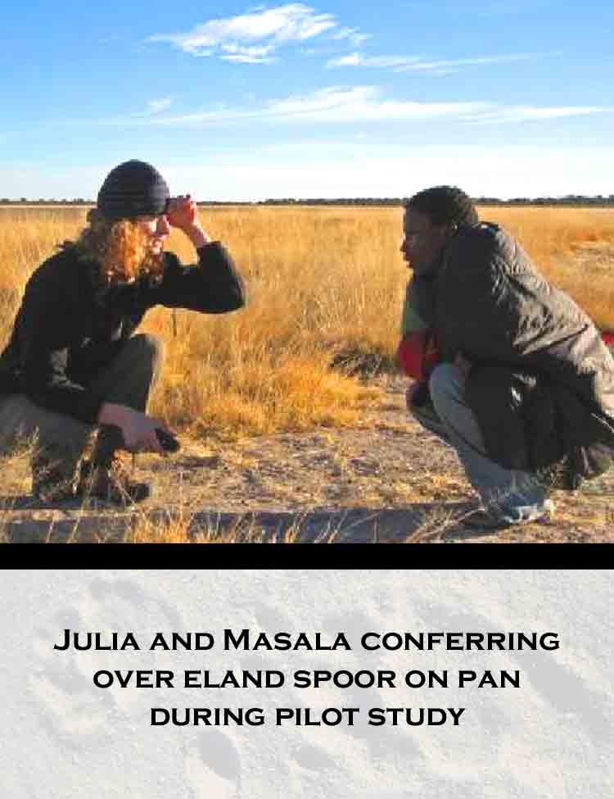
During August 2006, Dr. Lee Foote, along with graduate student Derek Keeping and research assistant Julia Burger, traveled to Botswana on a FSIDA (Fund for the Support of International Development Activities) grant and personal savings to meet and brainstorm with in-country colleagues, secure in-country support, and field test our track transect methodology with trackers from the local community trust trackers in the study area. Local game guards, community members, and government wildlife officials encouraged us to begin this work and our simple track sweep method readily revealed multiple species not detected during aerial surveys including Lion, Brown hyena, Honey badger, Bat-eared fox, Porcupine, Suricate, and Kori bustard. The team has since obtained a research permit from the government of Botswana, inviting them to begin this work.

Project Design and Methods:
a. Goals
1. Test a new method of assessing mammal populations through systematic line transect track surveys for comparison with conventional aerial surveys.
2. Test hypothesis that vertebrate diversity is inversely proportional to intensity of human land use.
3. Describe species distributions and associations with environmental variables such as other species, habitat and landscape features.
4. Improve community-based wildlife monitoring by exploring a practical, scientifically-defensible methodology local people can use to monitor wildlife.
b. Specific Aims
1. i) Conduct a sequence of track sampling through wet and dry seasons for one year to provide a robust measure of wildlife abundances, and a baseline with which to monitor changes through time.
ii) Collaborate with the Botswana Department of Wildlife and National Parks (DWNP) to estimate on-ground visibility correction factors (VCF) to increase the accuracy of existing aerial wildlife surveys.
2. i) Quantify differences in abundances and diversity of mammal species across a gradient of human land use intensity.
3. i) Use geo-referenced animal locations to characterize wildlife community composition and habitat associations of resident nocturnal and rare species such as black-footed cat, aardvark, and ground pangolin.
ii) Examine changes in presence, abundance, and movement directions across the study landscape to hypothesize annual movements of large, semi-migratory species.
4. i) Employ San trackers throughout the year to assist in identifying and interpreting animal tracks and sign in exchange for learning the details of scientific transect survey techniques.
ii) Collaborate with and build capacity in the Nqwaa Khobee Xeya Community Trust (NKXT) for understanding science-based monitoring and quota-setting procedures.

iii) Develop a “best practices” manual for community, government, and NGO use. This manual will detail the track transect technique and simple analyses for wildlife enumeration and comparison with government aerial surveys.
c. Methods
Throughout the study we will employ Bushmen trackers who readily and consistently identify all mammal species mongoose-sized and larger by tracks ²⁵. Some trackers can reliably determine sex and even individuals of certain larger species, and their age-old techniques of following animals and interpreting their behavior have been utilized in previous studies and regarded with much value towards modern wildlife ecology and conservation ^{24, 27}.
With our local partners we will establish and maintain a set of track transects covering the study area. Approximately 15 track transects (5-20 km long each) will be selected that coincide with lightly used sand 4x4 trails bisecting the study area. Transect selection and length will be proportional to the percentage of vegetation type within each land use area. We will also coordinate with the DWNP to overlap aerial survey transects with on-ground track transects during the dry and wet season annual aerial surveys.
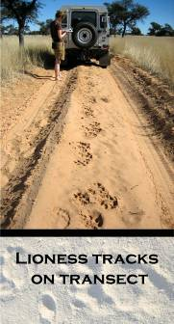
Our tracking partners will assist in track identification and interpretation along transects from an open-topped 4x4 vehicle driven at a steady rate (approximately 10km/hr). Transects will be swept clear of old tracks by dragging a rough broom behind the vehicle, and then sampled 24 hrs later. Two observers sit on the front hood/bumper scanning for and identifying animal sign, while a third observer records the track sets with GPS locations, and a fourth observer drives the vehicle. All mammal species mongoose-sized and larger, along with Ostrich and Kori bustard will be recorded along with direction of movement. Groups that cannot be identified to species but are still of interest will be recorded to generate indices of relative abundance, including tortoises, snakes, korhaans, and other game birds. Sampling rules will handle multiple crossings and parallel travel issues. Sampling will begin in the wet season and continue for one year. The appeal of this track transect approach is enhanced by the fact that it is inexpensive, low-tech, and almost completely non-invasive for the wildlife studied. No wildlife handling is required. The low-tech nature of this method also makes it low risk and less prone to equipment or personnel failure. These simple yet elegant track transect methods will reveal dimensions of data necessary to achieve our goals.
The study design allows comparison of abundances and diversity measures between three land uses since the area of different habitats sampled in each will be constant. Abundance indices and diversity metrics will be compared quantify the impact of current human activities on Kalahari wildlife. Where track transects and aerial transects coincide spatially, species observations will be compared between the two methods to estimate VCFs for large species for aerial survey. VCF’s will be estimated in both wet and dry seasons to determine the extent of visibility bias caused by vegetation changes. For each track transect abundance indices will be calculated simply as the number of individual track sets per 100km ²⁸. These indices will be calculated for all species and species groups. This baseline data will provide a very powerful tool in detecting changes in relative abundances through time and space and adjusting land use decisions and harvest quotas accordingly. All track location data will be imported into a spatially explicit, digital vegetation base map from satellite imagery to visualize changes in animal distributions and relationships to the real landscape. Data will be analyzed using ArcGIS software ²⁹. Using changes in abundance and net directional movements from track observations, large semi-migratory species’ movement patterns will be examined in relation to season. Resident species locations will be examined in relation to a variety of environmental variables including vegetation attributes, land use, cattle grazing, hunting pressure, and proximity to pans (water/mineral sources). This will be done using ordination techniques ³⁰.

Involvement of local people:
a. Local professional development
Local ownership over natural resource decisions is now widely viewed as the best way to conserve wildlife on communal lands in Africa. Botswana has introduced Community-based natural resource management (CBNRM) policies within the country’s WMAs to improve the livelihoods of the economically disadvantaged communities while conserving. The KD1 villages in the project area have been able to form a community trust, the Nqwaa Khobee Xeya Trust (NKXT), develop a land use plan, and enter into lease agreements with a photographic safari company and hunting concession. Mainly from the hunting concession, they are currently earning about US$50,000 per year. The lack of community organization in the other districts in the region has been a major hurdle to the CBNRM initiative. Communities to this day remain poorly organized and a general tension exists as a result of their lack of decision-making authority with regards to land use and quota-setting procedures.
Very little wildlife monitoring has been conducted by local communities. No standardized, long-term wildlife monitoring program exists at the community level although this is an explicitly recognized goal in Botswana’s CBNRM policy and generally viewed as fundamental to the success of CBNRM. Bringing our professional experience with mammal tracking techniques from the snow regions of Canada, and through emphasizing the existing exceptional tracking skills of the Kalahari San, the track-transect techniques may represent a practical, scientifically-defensible, and eventually self-sustaining solution communities can use to monitor wildlife, given the history and current widespread knowledge of animal sign and local ecology. The method does not require a high degree of expertise by field personnel.
  - Involvement of local people
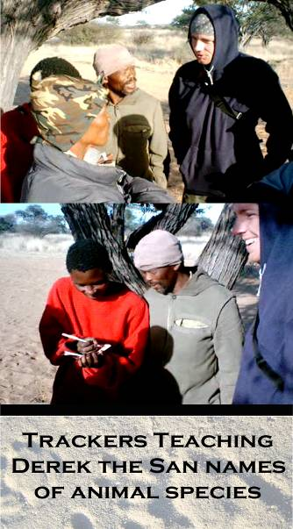
This study is a blend of ancient traditional knowledge and modern science. At least two local hunters will be employed at any given time throughout the one year duration of this project. On a daily basis we will be reciprocating knowledge with these individuals: their tremendous ecological knowledge of the area and interpretation of animal sign and behavior in exchange for our scientific perspectives. There is much to be learned on both sides and potential value to emerge from this kind of traditional-modern partnership. Aside from the expert trackers that we will employ directly, regular contact will be made with the community trust to share knowledge through monthly discussion meetings and by the fireside. In addition to the data gained from tracking, we will be informally inquiring into wildlife population trends and general local ecology perspectives from community members and elders and exploring ways of incorporating this knowledge into modern monitoring and management.

c. Education/public information
Throughout the field study, our efforts will be aimed at improving participation in data collection and understanding science-based monitoring and quota-setting procedures. We plan to give our trackers a detailed understanding of the methods we use to pass on to others in the community. This year-long project is a necessary preliminary to a larger vision of community development. We accept that the community may not have the capacity to manage information and collaborate with the government after our year of working with them. This is why we envision a “Phase 2” expansion of this project: an ambitious assistance program aimed at developing self-sufficiency within the NKXT in their wildlife monitoring and decision-making activities. This work may extend for multiple years. By the end of our one year project term “Phase 1” however, we will have completed the essential methodological work and plan to have instilled a foundation of understanding of science-based monitoring procedures within the community trust. Further, at least two trackers will understand the methods intimately and will be able to teach others. By the end of our year-long study we will have established the system of track transects throughout the area and started a hard copy database for the community trust. We will also produce and disseminate what is learnt from this unique experience through a “best practices” manual for our host community, other CBNRM initiatives, and libraries throughout Botswana.

Post-project follow-up :
a. Dissemination of results
Throughout this project we will work closely with our partners the Botswana Department of Wildlife and National Parks (DWNP) and the Nqwaa Khobee Xeya Trust (NKXT). We will provide them with all the raw data, progress updates, reports, and publications. We anticipate that the analyses may reveal immediate implications to current land use and wildlife quotas and we will make certain that the DWNP has the necessary information to affect immediate changes. Preliminary findings will also be shared with cooperating researchers and graduate students at the Harry Oppenheimer Okavango Research Centre (HOORC) and the University of Botswana. A manual on best practices, the track transect techniques, and simple statistical methods will be created and distributed to the NKXT, DWNP, HOORC, along with University and NGO libraries throughout Botswana. We anticipate multiple international peer-reviewed publications along with popular non-academic publications from this work.

b. Possible post-project conservation action
This project is committed to returning benefits to conservation and local people in the Kalahari. Although the immediate field work will be a year in duration, we will maintain our relationship with the DWNP and NKXT. Hypotheses may evolve that require further investigation once this year-long project is complete. Our work is likely to reveal many species-specific questions relevant to their conservation and may require investigations through backtracking and collaring studies. The community capacity-building Phase 2 of this project will involve a number of years further work.
c. Evaluation: how will success be measured?
Success will be measured by our ability to:
1. Determine if many species are currently undetected by aerial surveys yet are present in the study area.
2. Provide accurate abundance estimates for wildlife species that compliment and improve those of conventional aerial surveys.
3. Establish a baseline of species abundances for comparison with future long-term monitoring.
4. Reveal hitherto unknown knowledge regarding the effects (or lack thereof) of current land use on mammal abundances and the habitat associations of rare resident species in this remote environment.
5. Leave behind a capacity within our tracking partners and the larger community trust that will help them become self-sufficient in monitoring.
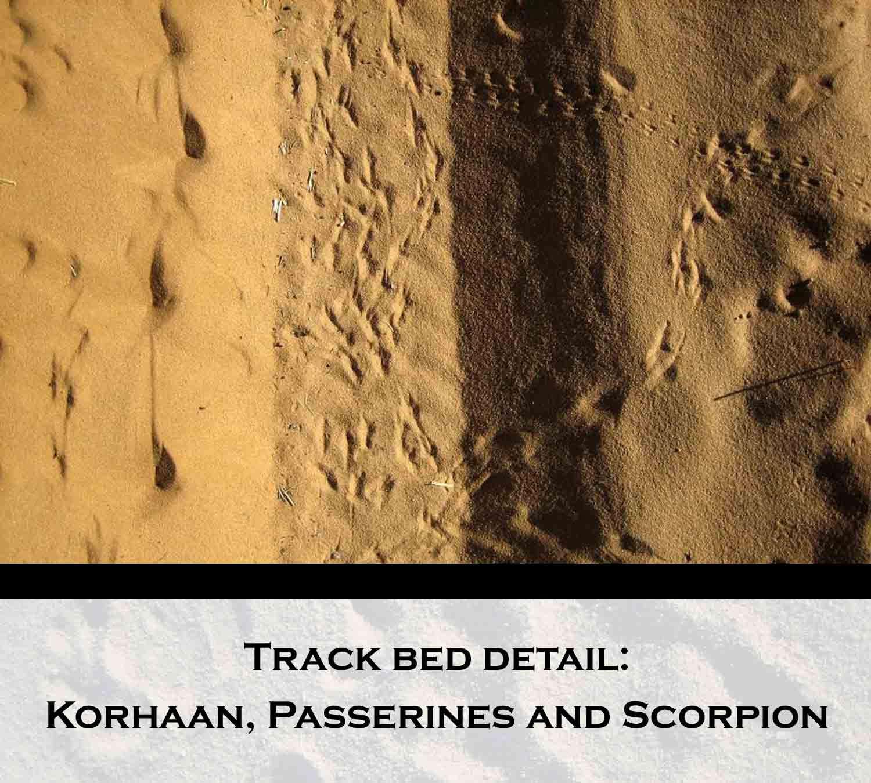

The following two pages are representations of the current flow of decision-making compared to the improved flow of decision-making that is supported by this project.

Current flow of decision-making affecting subsistence communities:

Government aerial wildlife survey
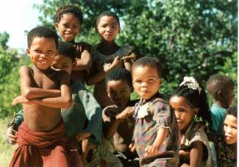
Communities
Currently weak to no input from communities regarding wildlife and land use decisions
Set for
Wildlife Quotas

Basis for

- Current decision-making involves a single source of data (Government aerial wildlife survey) in determining wildlife quotas and other decisions that strongly impact the potential of local communities. There is no effective feedback from communities regarding these decisions such as where, when, and how many animals can be hunted. Current quotas are set very conservatively by the government due to limited knowledge of wildlife trends.

Improved flow of decision-making affecting subsistence communities:

Government aerial wildlife survey
Wildlife Quotas

VCFs
Strong foundation for
Traditional
Knowledge
Track-based monitoring
Communities
Conduct

- The improved flow of decision-making affecting communities involves three knowledge inputs to wildlife decisions instead of one: aerial survey, community-conducted track monitoring, and traditional knowledge of wildlife. This flow involves strong feedback links and collaboration between local communities and governments in wildlife and land use decisions.

Budget For One Year:

Item/Activity Category | Description | Total Project Expenses in US$
Salaries for field staff & assistants | local trackers: 2 * ($9/day based on current wages, ~20d/mo, 250d/yr) = $4500  research assistant: ($500/month) = $6000 | $10,500
Food/per diems (specify # of people at daily rate for # of days) | 2 persons, $8/day, 365 days | $5840
Purchased services | vehicle insurance ($50/mo) | $600
Equipment $250-$5,000 (please list) | Folding solar panel, power inverter, adaptors, DC battery - $320  fuel tanks/water tanks - $250  “Meru” wall tents for temporary base camp - $4000 | $4570
Equipment over $5,000 (please list) | reliable, used 4x4 vehicle | $18,000
Expendable supplies & materials | notebooks, stationary, first-aid, water sanitation, data storage disks | $300
Maintenance | vehicle maintenance - $50/mo | $600
Travel - local (day) | petrol/diesel – 8km/L, 100km/day -$0.90/L - $3500  budget rental car/petrol – 2 weeks, $30/day, (to pick up 4x4, supplies, in Gabarone) - $420 | $3920
Travel - overnight | 2* economy roundtrip airfare, extra baggage fees | $6000
Miscellaneous | camp supplies (stove,table,chairs,etc.) - $1300 | $1300
TOTAL |  | $51,630
All other gear personally provided.

funding already secured:

- Natural Sciences and Engineering Council of Canada (NSERC) $17,500
- University of Alberta (U of A) $ 5,000
- Safari Club International – Northern Alberta Chapter (SCI-NAC) $ 1,000 Total funding in place: $23,500

We have not yet secured funding for a reliable, used 4x4 vehicle necessary to cover large distances in deep sand throughout the year with our tracking partners. A reliable Land Cruiser with about 200,000km goes for between $15 and $25K in South Africa. We also need critical supplies for maintenance and repairs plus fuel for the year which we estimate to cost about $3500. The other item we have not yet secured funding for is roundtrip economy airfare for 2 from Edmonton to Johannesburg.

Selected Bibliography:

¹Seber, G. A. F. 1982. The estimation of animal abundance and related parameters. Oxford Univ. Press, NY. pp.654.
²Pollock, K. H., and Kendall, W. L. 1987. Visibility bias in aerial surveys: a review of estimation procedures. J. Wildl. Manage. 51:502-510.
³Spinage, C. A. 1992. The decline of the Kalahari Wildebeest. Oryx. 26:147-150.
⁴DWNP. 1995. Status and trends of selected wildlife species in Botswana. Department of Wildlife and National Parks. Gaborone, Botswana.
⁵Owens, M., and Owens, D. 1980. Fences of death. Wildlife. June(214):214-217.
⁶Campbell, A. 1981. A comment on Kalahari wildlife and the Khukwe Fence. Botswana Notes and Records. 13:111-117.
⁷Knight, M. H., 1995. Drought-related mortality of wildlife in the southern Kalahari and the role of man. Afr. J. Ecol. 33:377-394.
⁸Chanda, R., O. Totolo, N. Moleele, M. Setshogo and S. Mosweu. 2003. Prospects for subsistence livelihood and environmental sustainability along the Kalahari Transect: The case of the Matsheng in Botswana's Kalahari rangelands. J. Arid Envir. 54:425-445.
⁹Parris, R. and G. Child. 1973. The importance of pans to wildlife in the Kalahari and the effect of human settlement on these areas. Journal of South African Wildlife Management Association. 3:1-8.
¹⁰Knight, M. H., Knight-Eloff, A. K. and Bornman, J. J. 1988. The importance of borehole water and lick sites to Kalahari ungulates. J. Arid Environ. 15:269-281.
¹¹Williamson, D. T., Williamson, J. and Ngwamotsoko, K. T. 1988. Wildebeest migration in the Kalahari. Afr. J. Ecol. 26:269-280.
¹²Bonifica. 1992. Aerial Surveys Report 1989-1991, 3 Vols. Department of Wildlife and National Parks. Gaborone, Botswana. Pp. 400.
¹³Herremans, M. 1998. Conservation status of birds in Botswana in relation to land use. Biological Conservation. 86:139-160.
¹⁴Verlinden, A. 1998. Seasonal movement patterns of some ungulates in the Kalahari ecosystem of Botswana between 1990 and 1995. Afr. J. Ecol. 36:117-128.
¹⁵Moleele, N.M. and J. Mainah. 2003. Resource use conflicts: the future of the Kalahari ecosystem. J. Arid Envir. 54: 405-423.
¹⁶Verlinden, A. 1997. Human settlements and wildlife distribution in the southern Kalahari of Botswana. Biological Conservation 82:129-136.
¹⁷Granlund, L. 2001. The abundance of game in relationship to villages, livestock and pans - a study in southwestern Kalahari, Botswana. Committee of Tropical Ecology, Uppsala University. Minor Field Study 73, MSc thesis.
¹⁸Wallgren, M. 2001. Mammal communities in the Southern Kalahari - distribution and species composition. Committee of Tropical Ecology, Uppsala University. Minor Field Study 69, MSc thesis.
¹⁹Viio, T. 2003. Does land use affect mammal diversity in savannah ecosystems? Evolutionary Biology Centre, Uppsala University. Undergraduate Thesis in Biology.
²⁰Bergstrom, A. 2004. Small mammal diversity in the Kalahari - impact of land-use and pans in a semi-arid savanna, southwestern Botswana. Committee of Tropical Ecology, Uppsala University. Minor Field Study 105, MSc thesis.
²¹Astrom, J. 2003. Insect communities in the Southern Kalahari - distribution and species composition. Committee of Tropical Ecology, Uppsala University. Minor Field Study 89. MSc thesis.
²²Melville, H. I. A. S., and Bothma, J. du P. 2006. Using spoor counts to analyse the effect of small stock farming in Namibia on caracal density in the neighbouring Kgalagadi Transfrontier Park. J. Arid Environ. 64:436-447.
²³DWNP. 1998. Progress in Wildlife Research in Botswana. Report to the Nation. Department of Wildlife and National Parks. Gaborone, Botswana.
²⁴Stander, P. E. 1997. Tracking and the interpretation of spoor: a scientifically sound method in ecology. J. Zool. Lond. 242:329-347.
²⁵Liebenberg, L. 1990. “The Art of Tracking The origin of science.” David Philip Publ., Cape Town. pp.176.
²⁶Spinage, C. A., and Matlhare, J. M. 1992. Is the Kalahari cornucopia fact or fiction? A predictive model. J. App. Ecol. 29:605-610.
²⁷Teer, J.G. 1982. Advances in wildlife management techniques. Transactions of the International Congress of Game Biologists. 14:397-407.
²⁸Stander, P. E. 1998. Spoor counts as indices of large carnivore populations: the relationship between spoor frequency, sampling effort and true density. J. App. Ecol. 35:378-385.
²⁹ESRI Environmental Systems Research Institute Inc., Redlands, CA.
³⁰ter Braak, C. J. F. 1986. Canonical correspondence analysis: a new eigenvector technique for multivariate direct gradient analysis. Ecology. 67:1167-1179.

Appendix

IUCN Red List status of mammal species:
There are over 40 species that we will assess through track monitoring. Listed below are only those species of greater status than Least Concern (LC):
- AFRICAN WILD DOG Lycaon pictus (Endangered C2a(i))
- CHEETAH Acinonyx jubatus (Vulnerable)
- BLACK-FOOTED CAT Felis nigripes (Vulnerable C2a(i))
- AFRICAN LION Panthera leo (Vulnerable A2abcd)
- GROUND PANGOLIN Manis temminckii (Near Threatened)
- BROWN HYAENA Hyaena brunnea (Near Threatened)
- HARTEBEEST Alcelaphus buselaphus (Lower Risk: Conservation Dependent)
- SPRINGBOK Antidorcas marsupialis (Lower Risk: Conservation Dependent)
- BLUE WILDEBEEST Connachaetes taurinus (Lower Risk: Conservation Dependent)
- SPOTTED HYAENA Crocuta crocuta (Lower Risk: Conservation Dependent)
- GIRAFFE Giraffa camelopardalis (Lower Risk: Conservation Dependent)
- ELAND Taurotragus oryx (Lower Risk: Conservation Dependent)
- GEMSBOK Oryx gazelle (Lower Risk: Conservation Dependent)
- GREATER KUDU Tragelaphus strepsiceros (Lower Risk: Conservation Dependent)

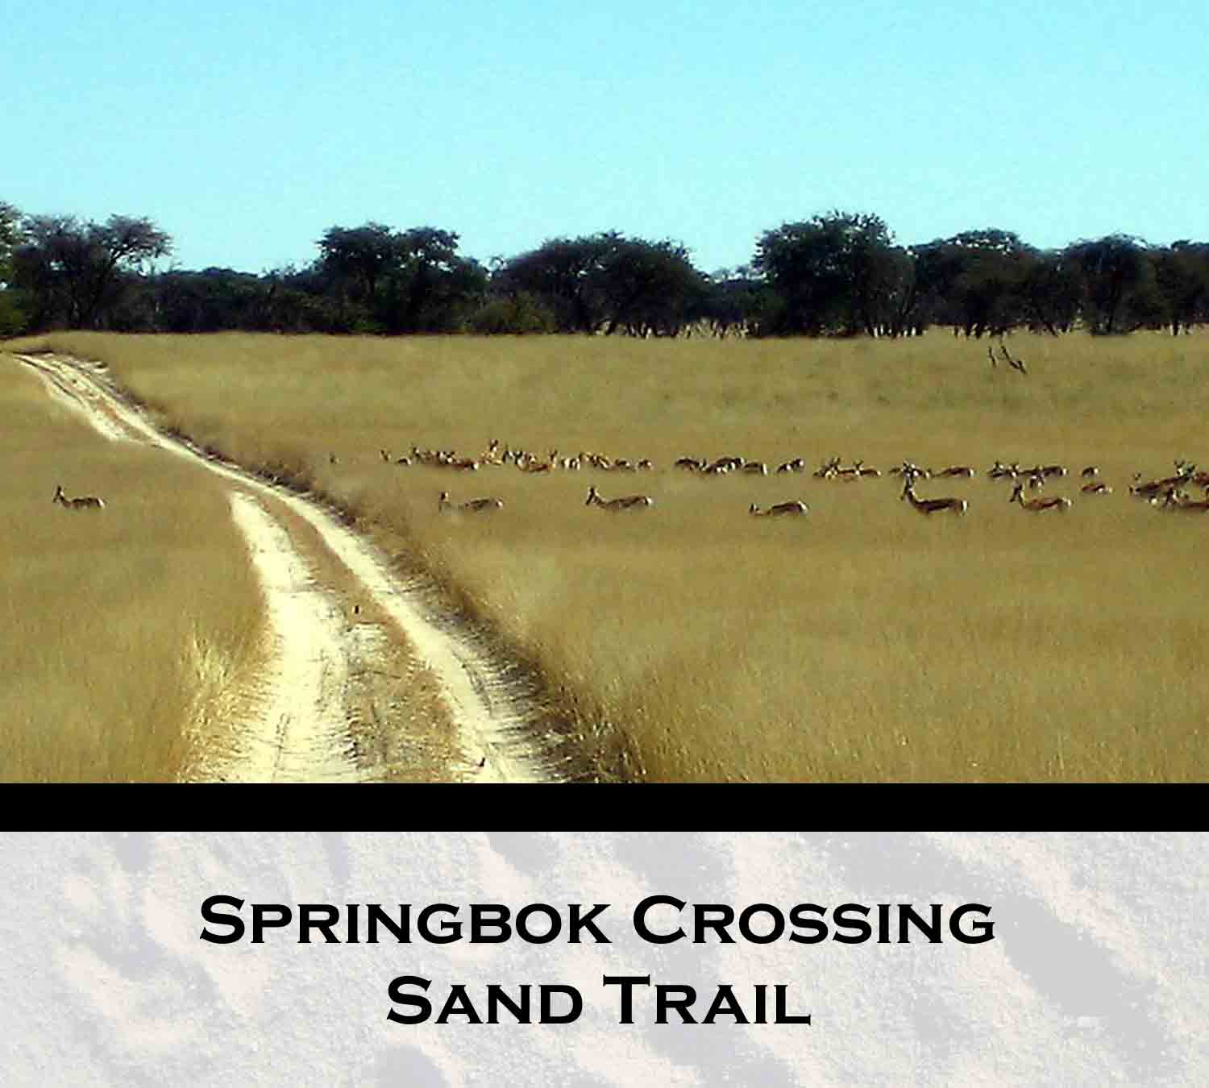

Research Permit from the Government of Botswana
Telephone: 3914955 Ministry of Environment,


Telegrams: MEWT Wildlife and Tourism

Telex: Private Bag BO 199
REPUBLIC OF BOTSWANA
Telefax: 3914861 Gaborone
Reference: EWT 8/36/4 I (21)

ALL CORRESPONDENCE MUST BE ADDRESSED TO
THE PERMANENT SECRETARY

Derek Keeping 30 July 2007
751 General Service Building
University of Alberta
Edmonton, Alberta
Canada, T6G 2H1

Dear Sir,

APPLICATION FOR A RESEARCH PERMIT:
“WILDLIFE ASSESSMENT OF KALAHARI ECOSYSTEM (WAKE)”

Reference is made to your application for research permit dated the 15th May 2007 on the above subject matter.

We are pleased to inform you that you are granted permission to conduct a research entitled “Wildlife Assessment of Kalahari Ecosystem (WAKE)”. The research will be conducted in the following places; KD1, KD3, KD2, Ngwatle, Ukwi, Ncaang, Zhutswa and Kgalagadi Transfontier Park (Botswana side).

The permit is valid for a period of twenty (20) months effective from the 1st September 2007 to the 30th April 2009.

The permit is granted subject to the following conditions:

- Signing and submission of an Agreement between Government of Botswana and Independent Researchers (enclosed).

- Copies of any videos/publications produced as a result of this project are directly deposited with the Office of the President, National Assembly, Ministry of Environment, Wildlife and Tourism, Department of Wildlife & National Parks, Department of Animal Health and Production, National Archives, National Library Service, Research and Development Office, and the University of Botswana Library.

- The permit does not give authority to enter premises, private establishments or protected areas. Permission for such entry should be negotiated with those concerned.

- You conduct the study according to particulars furnished in the approved application taking into account the above conditions.

- The research team comprise of: Derek Keeping, Dr Lee A. Foote and Julia Berger.

- Failure to comply with any of the above conditions will result in the immediate cancellation of this permit.

Regarding Nqaa Khobee Xeya trust, you should work closely with the Department of Wildlife & National Parks to ensure that undue expectations are not raised among trust members with regard to setting of quotas for any wildlife species that occur within the hunting concession areas.

Lastly, you are advised to provide full names of local trackers as soon as they are appointed.

Thank you.

Yours faithfully,

E. B. Moabi
for/PERMANENT SECRETARY

cc: Director of Wildlife & National Parks

